Project Design Phase-II
Data Flow Diagram & User Stories

Date | 06-04-2026
Team ID | 69bd2f9cc71a9ebd6a50e3b1
Project Name | smart library request workflow in service now
Maximum Marks | 4 Marks

Data Flow Diagrams:
A Data Flow Diagram (DFD) represents how data moves within the Smart Library system. It shows how users interact with the system, how requests are processed, and how data is stored.

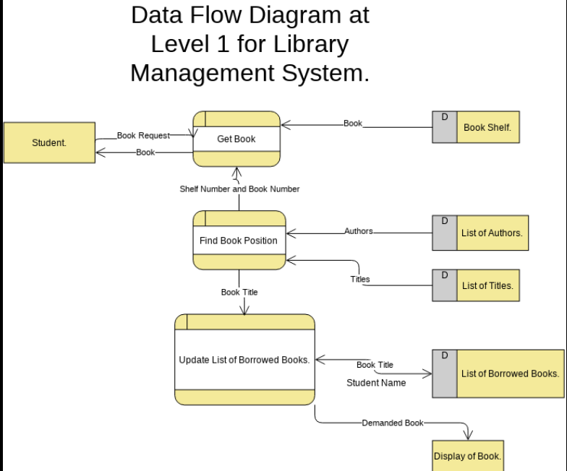

User Stories
Use the below template to list all the user stories for the product.
User Type | Functional Requirement (Epic) | User Story Number | User Story / Task | Acceptance criteria | Priority | Release
Student (Mobile/Web user) | Registration | USN-1 | As a user, I can register using email and password | I can create account and login | High | Sprint-1
Student | Registration | USN-2 | As a user, I receive email confirmation after registration | I can verify my account via email | High | Sprint-1
Student | Login | USN-3 | As a user, I can log in using credentials | I can access dashboard | High | Sprint-1
Student | Login | USN-4 | As a user, I can search books by title/author | I can view book availability | High | Sprint-1
Student | Book Search | USN-5 | As a user, I can request a book | Request is submitted successfully | High | Sprint-1
Student | Book Request | USN-6 | As a user, I receive request status notifications | I get email/SMS updates | Medium | Sprint-2
Librarian | Notifications | USN-7 | As a librarian, I can approve/reject requests | Request status is updated | High | Sprint-1
Librarian | Approval | USN-8 | As a librarian, I can issue books to users | Book issue is recorded | High | Sprint-1
Librarian | Book Return | USN-9 | As a librarian, I can update book returns | Return status is updated | Medium | Sprint-2
Admin | Dashboard | USN-10 | As an admin, I can view reports and system data | Reports are generated correctly | Medium | Sprint-2
Admin | User Management | USN-11 | As an admin, I can manage users | I can add/remove users | Medium | Sprint-2

